7/17/2020

You have been recommended as a possible candidate for an open Supervisor Position on the South St. Louis Soil and Water Conservation District’s Board of Supervisors. Soil and Water Conservation Districts (SWCDs) are Local Units of Government (LGUs) with an elected Board of Supervisors much like a Township. There is at least one SWCD in every County in Minnesota, and two in St. Louis County (based in Duluth and Virginia). SWCDs work with private landowners, other Local Governments and State Agencies to protect and restore the crystal clear lakes and streams, the high-quality private and public tracts of woodlands, and the ubiquitous wetlands that provide so many benefits to our environment and local communities.

Though usually elected, the Supervisor position for District 1 is currently vacant and can now be appointed by the Board of Supervisors. The appointed Supervisor would serve through December 2022, with the ability to run November 2022 General election to remain on the Board.

Supervisors must commit to attending monthly meetings that typically last 1 – 2 hours. Regularly scheduled Board meetings are held monthly, on the third Wednesday of each month, at 7:00 pm. There may also be emergency meetings, though these are infrequent. Board meetings are held at the SWCD office in Duluth, which is located in the Historic Old Central High School Building in downtown Duluth. Supervisors are also asked to represent the District by serving on various committees and attending events.

There are many benefits to serving on the Board including:
1. Helping to shape local SWCD policy;
2. Meeting other Supervisors from around the State at annual meetings and training events;
3. Getting to know the SWCD staff and learning about current water quality and land stewardship issues, policies, and projects;
4. A per diem of $75 and mileage paid for attending Board and Committee meetings;
5. The satisfaction of participating in a local democratic process and of being a public servant.

If you would like to be considered for the open supervisor position for District 1 (see map below), would you kindly provide the following information and return the form to the SWCD office (215 N. 1st Ave E. #301, Duluth, MN 55802) or scan and email to RC.Boheim@southstlouisswcd.org by Tuesday August 11th. The Board will review all applicants and notify the appointed member following the August Board Meeting.

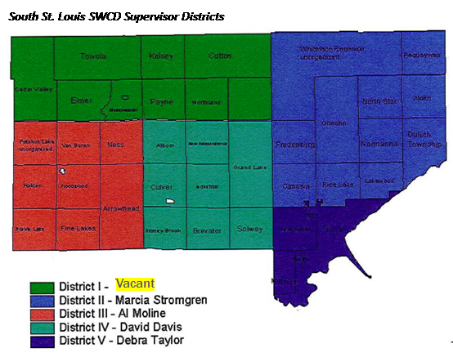

1.) Can you briefly explain why you would be interested in serving on the Board?

2.) Do you have any experience as an elected official (Township Board etc.) or experience serving on boards or committees voluntarily (Non-profit board, lakeshore association, etc.)?

3.) Are there any local natural resource issues that you are especially interested in, or would like to learn more about (wetland regulations, public access, invasive species, etc)?

Thank you for your interest. We will be in touch with you soon. ~ South St. Louis SWCD Board of Supervisors

